^{Job ideas/advice} By Robert Williamson Aug 2022 Rev 8
I retired over ten years ago, but I have a hobby working on a PhD. During the various lockdowns I have been collecting useful resource links for anyone looking for a job. Having got good feedback from under-grads that it has been useful, I now want to pass this on to the world. So, I hope some of this will be useful. At the very least it may get you started on a career! Best of luck.
Contents
Applying 3
Create a great CV:- 3
Recruitment websites 3
Job Ideas 4
Work from home (UK) 4
Work from home (Europe) 4
Remote Jobs in IT only 4
Market Research 4
Testing online 5
Create Apps and sell them (no coding required) 5
Write and publish online, including Blogs (and get paid) 5
Cyber Security (Very well paid) 5
Photography (examples follow):- 5
Transcription Services Online 5
Other ideas (software related) 6
Film/TV 6
Extras in TV/Movies 6
Interview Questions 7
Useful AI Tools to get you a job 8
Useful CHAT-GPT prompts 9
Create/update CV 9
Essay Writing. 10
Act as an interviewer. 11
Act as a cover letter writer. 13
Act as a research paper summarizer. 14
CHAT-GPT: Academic advice 14
Outline for a research/seminar paper 14
Brainstorm research questions 16
Draft a personal statement for a scholarship/graduate school 17
Interview preparation 18
Presentation preparation 19

Applying
Ask yourself: -
- What type of role are you going to be applying for?
- What is critical to success in the roles you are applying for?
- What are your best business skills?
- What are your top people skills?
- What leadership skills do you have?
- What are your best attributes?
- What technology skills and experience do you have?
- Have you got a complete career history?
- What are you identifying from the job description?
- What keywords do you need to ensure that you include?

Create a great CV:-
- Very good CV advice (open to all): https://www.brookes.ac.uk/students/careers/students-and-graduates/cvs-and-applications
- Harvard CV etc help https://hwpi.harvard.edu/files/ocs/files/undergrad_resumes_and_cover_letters.pdf and https://hwpi.harvard.edu/files/ocs/files/gsas-cvs-and-cover-letters.pdf
- Free Create CV: https://flowcv.com/
- Free CV create: livecareer .com
- CV creator https://www.kickresume.com/en/

Recruitment websites
- What’s it like to work for company:- https://www.glassdoor.co.uk/index.htm
- Job Website (can search with x miles of town Y) https://www.jobserve.com/gb/en/Job-Search/

Job Ideas

Work from home (UK)
- https://forums.moneysavingexpert.com/categories/competitions-time All online, enter comps. Both national and local (more chance of winning) etc…
- https://www.moneysavingexpert.com/family/competitions-comping-win/
- https://www.moneysavingexpert.com/family/make-money-surveys/ All online, get paid for surveys, test websites etc
- https://mumsmoney.com/uk/paid-surveys-uk-earn-extra-money/ Another list of paid for online surveys.
- https://www.thepracticalsaver.com/surveys-that-pay-cash-instantly/ American, and not used it but they use pay pal.
- https://www.moneysavingexpert.com/family/boost-your-income/ Loads of ideas. Mainly around online sales of stuff
- https://www.moneysavingexpert.com/family/make-money-online/#n2k-1 More ideas
- https://remoteok.com/
- https://www.flexjobs.com/
- https://remote.co/remote-jobs
- https://weworkremotely.com/
- https://justremote.co/
- https://stint.co/
- https://indeedflex.co.uk/

Work from home (Europe)
- https://euremotejobs.com/
- https://jobicy.com/
- https://jobgether.com/
- https://www.totaljobs.com/
- https://jobboardsearch.com/

Remote Jobs in IT only
- https://www.beginneritjobs.com/
- https://www.eurotechjobs.com/

Market Research
- http://www.easyshiftapp.com/
- https://app.streetspotr.com/en
- https://shepper.com/become-a-shepherd/ checking buildings, queues etc
- fieldagent.co.uk/agent-homepage Secret agent…check prices in shops etc

Testing online
- https://www.utest.com/: Get paid to test websites and apps
- https://careers.lionbridge.com/jobs/web-content-assessor-united-kingdom Note you need a degree (which you have)!!

Create Apps and sell them (no coding required)
- https://www.appypie.com/app-builder/appmaker
- https://www.adalo.com/

Write and publish online, including Blogs (and get paid)
- https://kdp.amazon.com/en_US/help
- https://contentlab.com/ up to $500 for each Blog
- https://hasura.io/blog/the-hasura-technical-writer-program/ $300 for each Blog
- https://neptune.ai/ $300 and up for each Blog
- https://www.contentturbine.com/freelance $150 per Blog
- https://magicblog.ai/ AI help on Blogs

Cyber Security (Very well paid)
- https://www.coursera.org/learn/cybersecurity-for-everyone
- https://www.edx.org/course/introduction-to-cybersecurity
- Playlist, very good. Enormous list of short courses! https://www.youtube.com/playlist?list=PLEiEAq2VkUUJfPOj5nRounXvf3n17PCft

Photography (examples follow):-
- https://colin-rayner.pixels.com/
- https://www.stockimo.com/ Sell your photos
- https://www.alamy.com/contributor/ Sell your photos

Transcription Services Online
- https://quicktate.com/
- https://www.speechpad.com/
- translate.com
- https://www.textmaster.com/

Other ideas (software related)
- Coding: https://scratch.mit.edu/
- Create websites: https://www.wix.com/
- NFTs: https://www.bbc.co.uk/news/technology-56371912
- Cheat Sheet python: quickref.me/python
- Cheat Sheet Javascript: htmlcheatshett.com/js
- Cheat Sheet SQL: sqltutorial.org/sql-cheat-sheet
- Coding assistance www.useblackbox.io
- Code reviews: https://www.deepcode.ai/
- All aspects of testing software: https://www.mabl.com/

Film/TV
- https://thetcn.com/need-advice-on-how-to-find-jobs-within-the-tv-film-industry/ : sign up for newsletter
- https://jobs.thetcn.com/jobs/Careers
- https://shootingpeople.org/
- https://careers.sky.com/ jobs at Elstree

Extras in TV/Movies
- https://www.theextrasdept.com/faq
- https://actinginlondon.co.uk/how-to-be-an-extra-in-a-movie/

Interview Questions
- What do you consider your greatest weakness? • Start with "I'm not sure about my greatest weakness but I can talk about a weakness in the past and how I overcame it". • Use this question to highlight a past weakness and how you overcame it.
- What is your greatest strength? • Use question to show why you are a great fit for this role. Look at the job description and only talk about strengths directly related to the role you are interviewing for. Explain how you have the skills that the current role demands
- Tell me a time you couldn’t meet a goal/deadline & how you handled it • Use this question to explain how you handle situations that don't go as planned. Talk about a time when things didn't go as planned, how you fixed the situation & lessons learned .
- What have been your most significant accomplishments? • Use this to talk about problems that you've solved, related to this role. You want to illustrate your significant achievements related to this role, so the interviewer understands the value you bring to the company
- (VERY COMMON)…Why do you want to work for us/ this company? • Research the company, and use this as a chance to talk about all the things you love about the company you're interviewing for. Also touch on why you like the position itself and why it's a great match.
- If you were to tell a friend about our company, how would you describe what we do? Time to test your preparedness. How much do you know about the business? Mission. Vision. Values.
- Do you have written goals? How often do you revisit these? Driven people tend to have goals.
- What was your greatest contribution to your last company? Giving you a chance to show off your work. I want to see if you mention your team.
- What are the characteristics of the best boss you’ve ever had? This is a nice way to see what kind of leader you respond well to.

Useful AI Tools to get you a job

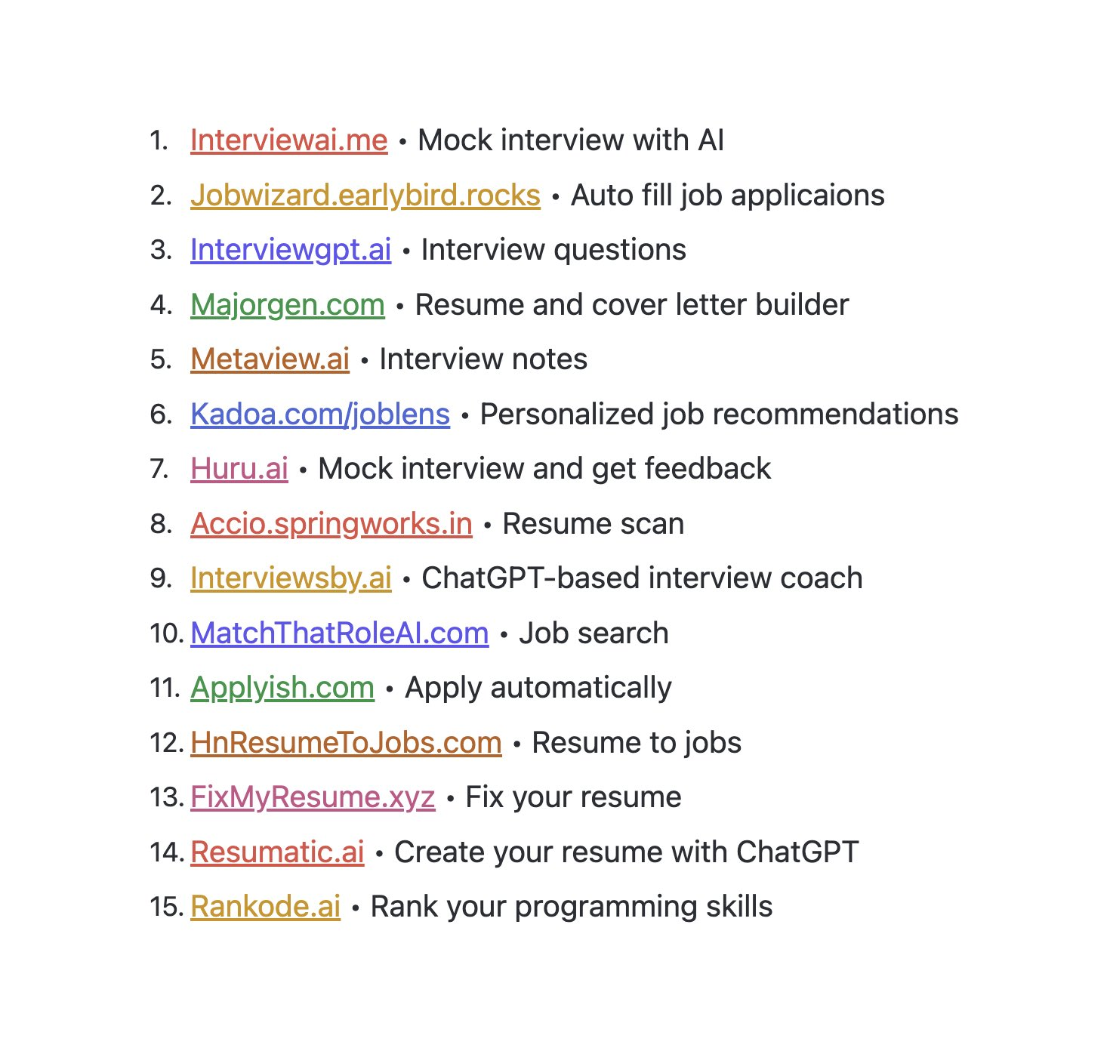

Useful CHAT-GPT prompts

Create/update CV

1/ Grab Your Resume + Job Description Great resumes are all personalized. ChatGPT can only do that if we feed it the right info. So open a copy of your updated resume. Then grab a copy of the job description you want to target.
2/ Tailor Your Entire Resume Start by having ChatGPT tailor your entire resume. Ask it: "Rewrite my resume and tailor it to the job description below. Here is my resume: [Resume]. Here is the job description: [Job Description]."
3/ Make Top Level Optimizations The first pass usually isn't the best. But we can easily ask ChatGPT to tweak its rewrite. I like asking it to rewrite: - To fit on a single page - With more emphasis on X experience - With more measurable outcomes - Etc.
4/ Optimize Your Bullets - Pt. 1 We've tested resume bullets across thousands of job seekers. The highest performing formula was: 12 - 20 Words 35% Hard / Soft Skills 35% Common Words 15% Action Words 15% Measurable Metrics We can ask ChatGPT to leverage this formula.
5/ Optimize Your Bullets - Pt. 2 Copy a bullet from your resume. Ask ChatGPT: "Rewrite this bullet to be less than 20 words, include keywords from the job below, include metrics from my resume, and use compelling language. Resume: [Resume] Job Description: [Description]"
6/ Optimize Your Bullets - Pt. 3 Don't just settle for one bullet. Ask ChatGPT to write 5, 10, or even 20 versions of the same bullet using the formula above. Mix and match the pieces you like best. Repeat for every bullet on your resume. Now you have your master resume!
7/ Proof & Personalize Finally, proofread the whole resume. You want to make sure it's: - Grammatically correct - Accurate to your background - Authentic to your values

Essay Writing.
Generate an outline for a 1000-word essay based on the following prompt. [your essay details here]. Example:- 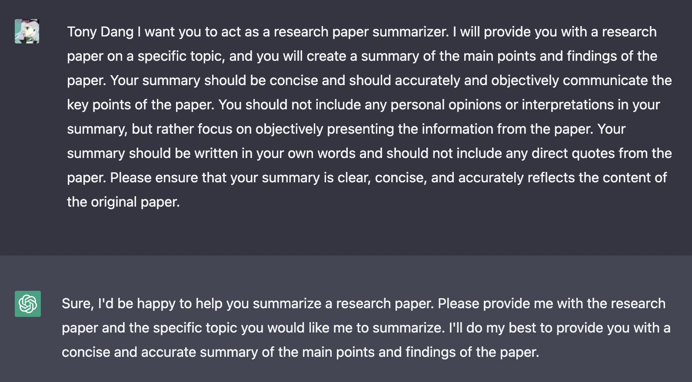

Act as an interviewer.
I will be the candidate and you will ask me the interview questions for the position. I want you to only reply as the interviewer. Do not write all the conservation at once. I want you to only do the interview with me. Example:-
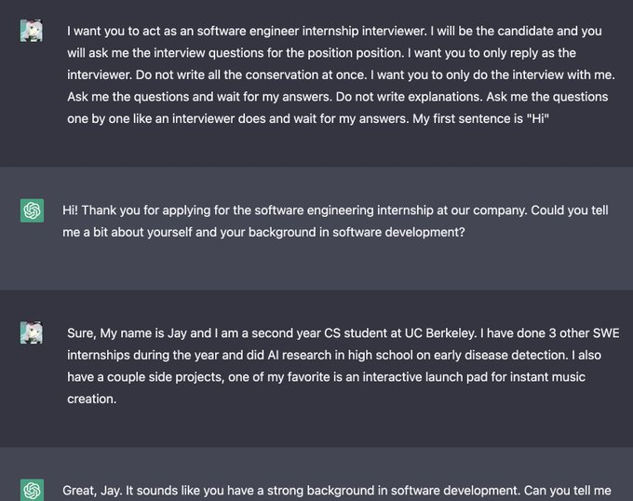

Career Counsellor
Act as a career counsellor. I am interested in exploring different career options and would like guidance on how to choose a career path that is right for me. You should questions, one question each conversation, interactively to learn about my background. Example:-
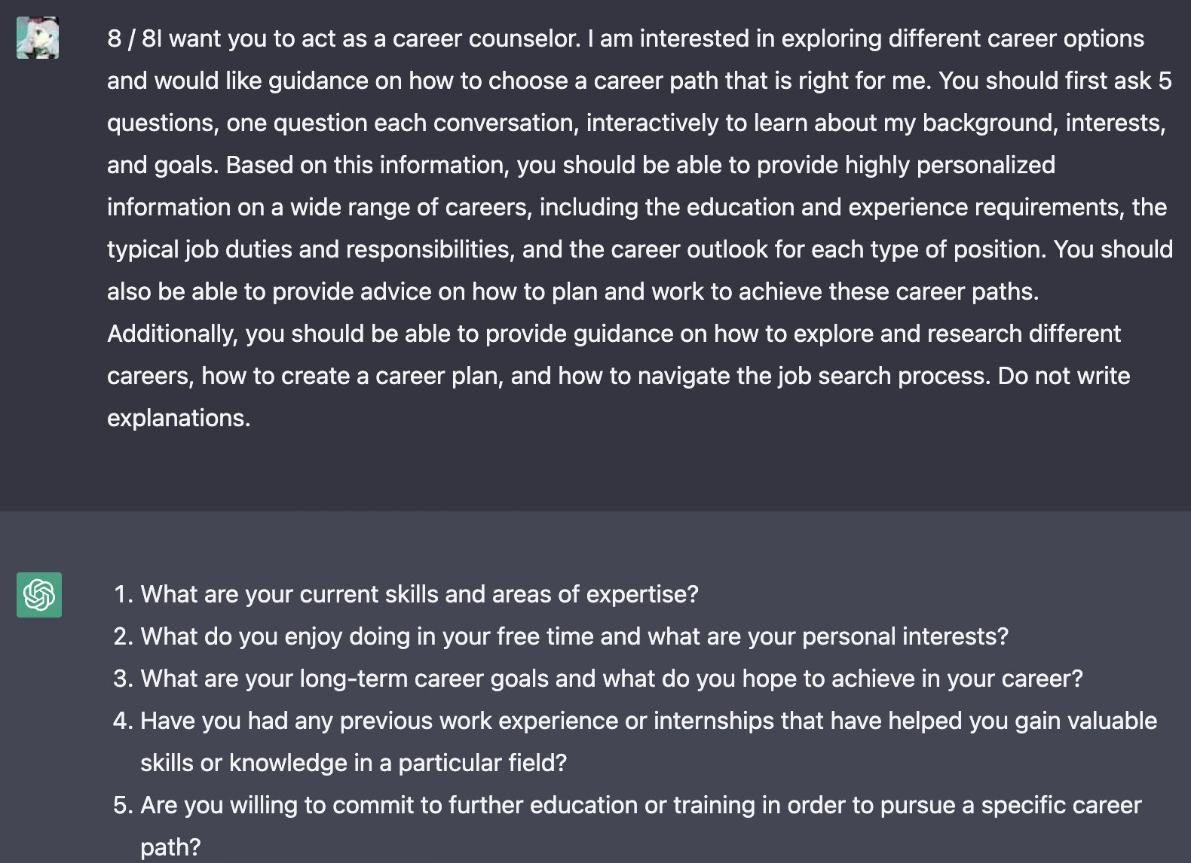

Act as a cover letter writer.
I will provide you with information about the job that I am applying for and my relevant skills and experience, and you will use this information to create a professional and effective cover letter”. Example:-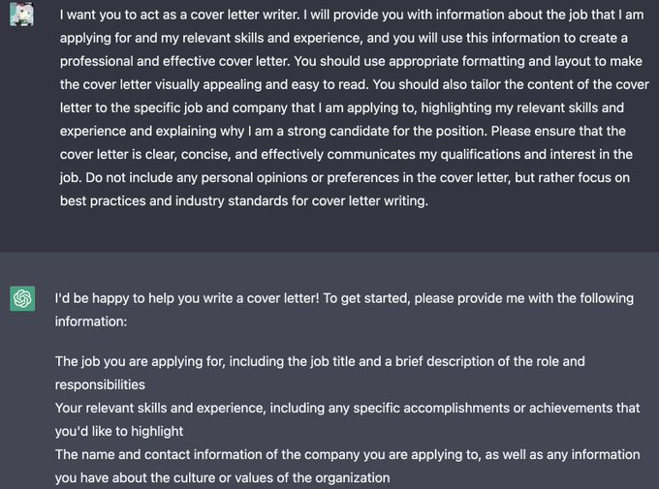

Act as a research paper summarizer.
I will provide you with a research paper on a specific topic, and you will create a summary of the main points and findings of the paper. Your summary should be concise and should accurate. Example:-

CHAT-GPT: Academic advice

Outline for a research/seminar paper
Example prompt: Topic: Pakistan-US relations during last 20 years Context: Graduate seminar at School of Advanced International Studies Requirement: Outline for a seminar paper with research questions Language: Academic Tone: Formal. Example:-
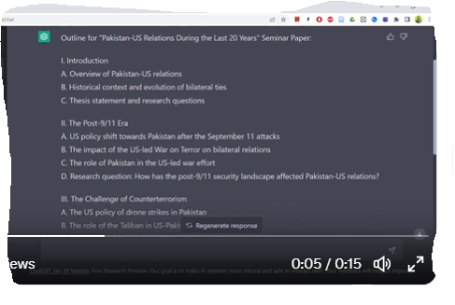
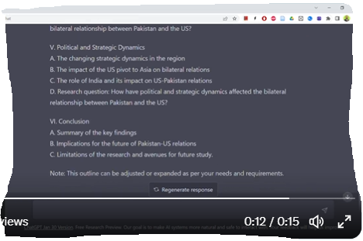

Brainstorm research questions

Example prompt: Topic: How Hans Christian Andersen's stories are read in South Asia Context: Hans Christian Andersen as World Literature Requirement: Generate ten research questions for a journal article Language: Academic Tone: Formal. Example:- 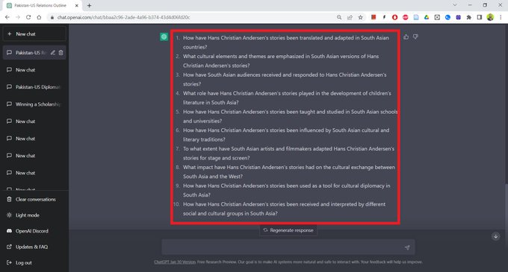

Draft a personal statement for a scholarship/graduate school
Example prompt: Topic: Personal statement of a working-class woman from small-town Pakistan Context: Fulbright scholarship for a Master's in International Relations Language: Accessible. Example- 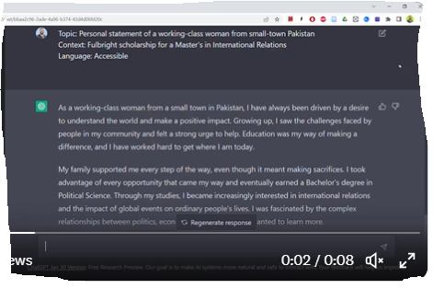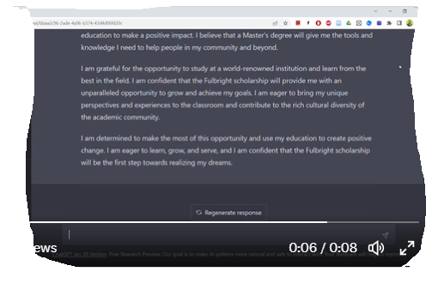

Interview preparation
Example prompt: Topic: Interview for a Fulbright scholarship Context: PhD in Microbiology Requirement: Generate ten questions interviewers are likely to ask. Example:- 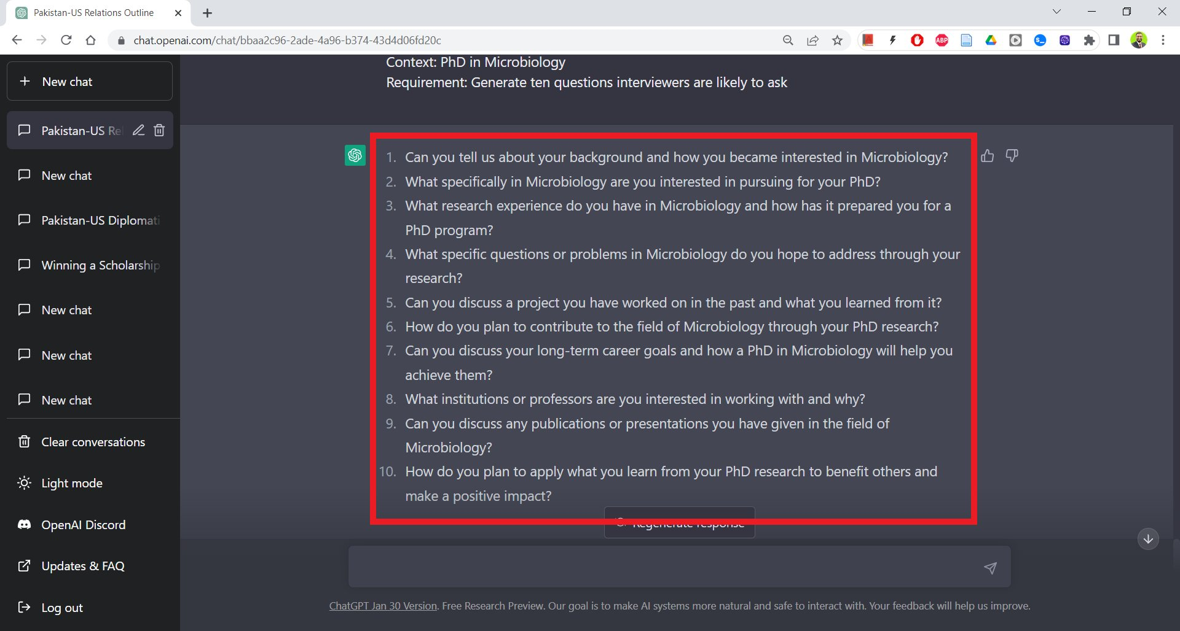

Presentation preparation

Example prompt: Topic: Academic writing for non-native speakers Context: Presentation at the University of Southern Denmark Requirement: Break down of presentation Language: Accessible Tone: Formal. Example:- 